# Lab Work for chapter 9.1 and Chapter 3

1. The following figure shows an ER diagram for a database that can be used to keep track of ships and their locations for maritime authorities. Use the 7-step algorithm to create the RM diagram of this ER, and specify all primary keys and foreign keys.

* Paste the picture of your RM here: (it is acceptable to draw on a paper and then paste its picture here, or use draw.io).

1. Based on the following ER diagram for the MOVIES database (It is different than the one you saw earlier), answer the questions related to this exercise.

* 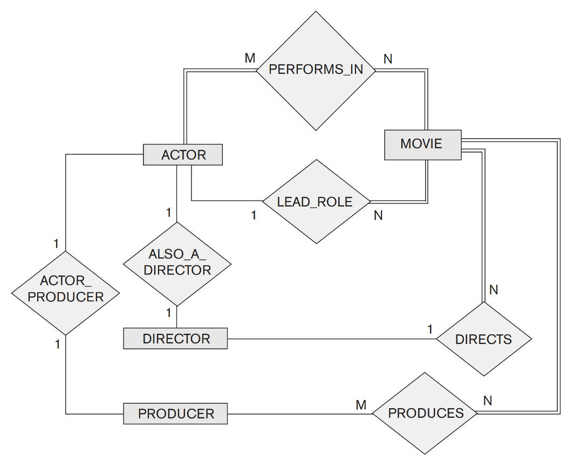ACTOR is used as a generic term and includes actresses. Given the constraints shown in the ER schema, respond to the following statements with *True, False*, or *Maybe*. Assign a response of *Maybe* to statements that, although not explicitly shown to be *True*, cannot be proven *False* based on the schema as shown. Justify each answer.

1. There are no actors in this database that have been in no movies.

*True, because participation of ACTOR in PERFORMS_IN is total.*

1. There are some actors who have acted in more than ten movies.

*Maybe*.

1. Some actors have done a lead role in multiple movies.

True, because the relationship between ACTOR and MOVIE using LEAD_ROLE is 1:N and 1 is some.

1. Every director has been an actor in some movie.

False, because the relationship between ACTOR and DIRECTOR is 1:1

1. No producer has ever been an actor.

False, because there is a relationship between PRODUCER and ACTOR.

1. A producer cannot be an actor in some other movie.

False,

1. There are movies with more than a dozen actors.

Maybe.

1. Some directors may not direct any movies.

False,

1. Movies have one director but can have several producers.

True, because

1. There are some actors who have done a lead role, directed a movie, and produced a movie.

True,

1. No movie has a director who also acted in that movie.

False,